AUTHOR / SCHOOL | Ināra Sprindžuka (Daugavpils City Education Department), Ilona Ustinova (Daugavpils City Education Department, Daugavpils Secondary School named after J.Rainis)
DATE OF CLIL ACTIVITY | September 2017
CLASS / NUMBER OF STUDENTS | 5 Form / 10 students (aged 10-12)
SUBJECT | ART
CLIL LANGUAGE | English
CLIL Activity Topic | COLOUR WHEEL
CLIL Activity Time | 40 minutes
Language Objectives | - Perceiving and exchanging information about the topic „Colour Wheel“  - Learning the names of the colours according to the groups: primary, secondary and tertiary, warm and cold/cool  - Imperative mood with the verbs name, mix and add.  - Questions in Present Simple
Language used for communication (BICS) | - Questions: What colours do you mix to get (green)? What colour do you add to (yellow) to make it (green)? What are (warm) colours? What colour is green?  - Imperative sentences: Name (cold) colours. Mix yellow and blue. Add yellow to blue. Make it green.
Content Language (CALP) | - Colours’ groups: primary, secondary, tertiary, warm, cold/cool;  - Verbs: to be, to mix, to add, to get, to make, to name
Content Objectives | - Understanding the colour wheel importance in colour-mixing  - Understanding and learning the groups of colours  - Colouring the picture using cold or warm colours  - Describing the picture using the description of colours groups
Materials / Resources used | 1.Video 1 – What colours do you like? (song)  https://www.youtube.com/watch?v=tQASh8bbkUY  2.Video 2 - Color Wheel Chart Primary Colors Secondary Colors Tertiary Colors  https://www.youtube.com/watch?v=a1R92StQHhs  3. www.reference.com (reading0
CLIL Activity - procedure | - 1. Warming up activity – singing the song which students learnt the previous lesson (4 min)  - What colours do you like? – song https://www.youtube.com/watch?v=tQASh8bbkUY  - Students revise the names of the colours. After singing they answer one question. What colour(s) do you like?  2. Introduction of the topic COLOUR WHEEL: Primary and secondary colours (4 min)  (students receive a handout (Appendix 1)  A teacher shows a model of the colour wheel and explains students how it works. Students receive a handout (Appendix 1). Then students read the text in handout 1.  3. Speaking: Answer the questions (3 min)  A Teacher asks and Students answer the questions based on the text:  - What does colour wheel show us?  - What does it remind artists about?  - What are the primary colours?  - Can we make primary colours from other colours?  - How are all other colours created?  - What are the secondary colours?  - How do we make secondary colours?  4.Speaking and writing. (3 min)  There are 3 picture chains below the text. Ask students to make 3 sentences and write them down.  - What colours do you mix to get orange? - I mix red and yellow to get orange.  - What colours do you mix to get green? – I mix yellow and blue to get green.  - What colours do you mix to get purple (violet)? – I mix blue and red to get violet.  5.Introduction of tertiary colours (5 min)  Teacher shows the video 2  (Color Wheel Chart Primary Colors, Secondary Colors, Tertiary Colors.  https://www.youtube.com/watch?v=a1R92StQHhs) which revises what are primary and secondary colours and explains how we get tertiary colours. (When we mix a primary and a secondary colours standing next to each other we get a tertiary colour.) Afterwards a teacher gives an example how we make tertiary colours.  e.g. We add yellow to green and make it yellow-green. OR We mix green and yellow to get yellow-green.  A teacher asks students to give their own example of making tertiary colours  6.Introduction of warm and cold/cool colours.(3 min)  A Teacher shows a colour wheel and divides it into 2 parts explaining simultaneously what warm and cold colours are.  Warm colours refer to the colors that remind you of the sun, sunset or of daytime. Examples of warm colours are red, yellow and orange, and these colours resemble fire and evoke feelings of warmth. Cool colours include shades of blue, green and violet, and the colors remind you of cool things like water or grass.  7.Drawing: Appendix 2 (12 min)  Students are divided into pairs. Each student receives a handout with a flower and colours it according to the task. The teacher decides who does the variant 1 and who – variant 2.  8.Speaking in pairs according to the given scheme (Appendix 3) (4 min)  9.Assessment (1 min)  Students fill in the self-evaluation form – Appendix 4
Performance Assessment | Students fill in the self-evaluation form – Appendix 4
TEACHER´S NOTES

Appendix 1
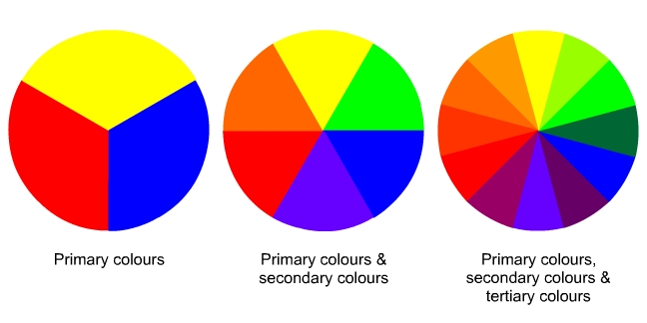

Colour wheels show us how colours are related. They remind artists how to mix and think about colours.
The primary colours are:
- red
- blue
- yellow
Primary colours cannot be made from other colours. Artists create all the other colours of the rainbow by mixing together the primary colours.
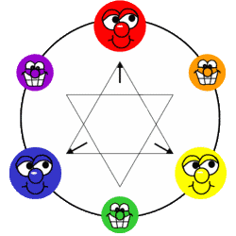

The secondary colours are:
- green
- orange
- violet (purple)
Secondary colours are made by mixing two primary colours. Each secondary colour is made from the two primary colours closest to it on the colour wheel.

Just by mixing these colours, you can get all the colours of the rainbow.

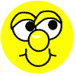





Appendix 2.
Drawing Task
Colour the the picture.
Use the following colours
Variant 1 | Variant 2
1. green  2. blue  3. violet  4. yellow-green  5. blue-green | 1. yellow  2. red  3. orange  4. yellow-orange  5. red-violet

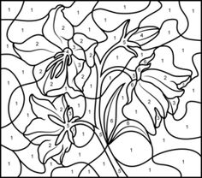

°

Appendix 3.
Choose your own version and speak
My picture is made of _______________________(warm/ cold) colours.
__________________________colours/colour are/is primary.
__________________________colours/colour are/is secondary.
__________________________colours/colour are/is tertiary.
I like/don’t like my picture.
What do you think of my picture?

Appendix 4
Self-evaluation (put a tick under the statement which corresponds to you)
 |  | Completely agree | I am not sure | Completely disagree
1 | I understand what is a Colour Wheel
2 | I know and understand the following groups of colours
2 | - Primary
2 | - Secondary
2 | - Tertiary
2 | - Warm and cold
3 | I can ask and answer questions about mixing and adding colours.
4 | I can describe my drawing using different groups of colours.

