AUTHOR / SCHOOL | Silvija Mickeviča (Daugavpils City Education Department), Ilona Ustinova (Daugavpils City Education Department, Daugavpils Secondary School named after J.Rainis)
DATE OF CLIL ACTIVITY | September 2017
CLASS / NUMBER OF STUDENTS | 5 Form / 10 students (aged 10-12)
SUBJECT | ART
CLIL LANGUAGE | English
CLIL Activity Topic | COMPLEMENTARY COLOURS.
CLIL Activity Time | 40 minutes
Language Objectives | - Perceiving and exchanging information about the topic „Complementary Colours“  - Revising colours according to the groups: primary, secondary and tertiary, warm and cold/cool  - Learning the pairs of complementary colours using the colour wheel  - Imperative mood with the verbs name, use, mix and add.  - Questions in Present Simple
Language used for communication (BICS) | - Questions: What colours do you mix to get (green)? What colours do you use to draw your picture  - Imperative sentences: Name (cold) colours. Mix yellow and blue. Add yellow to blue. Make it green. Describe your picture
Content Language (CALP) | - Colours’ groups: primary, secondary, tertiary, warm, cold/cool;  - Verbs: to be, to mix, to add, to get, to make, to name  - Complementary colours
Content Objectives | - Understanding and learning the groups of colours  - Colouring the picture using complementary colours  - Describing the picture using the description of colours’ groups
Materials / Resources used | 1.Video 1 – Complementary Colours (https://www.youtube.com/watch?v=QS3l-BKUl3g)  2.Video 2 - song “The Ballad of Red and Green” https://www.youtube.com/watch?v=ZSvkAHvxWr4
CLIL Activity - procedure | - Group work. (7 min)  Colour-wheel revision. Answer the questions Students are divided into 3 groups. Each group receives written questions (Appendix 1). Students answer in groups and then the whole class listen to the answers together and check.  - What primary colours do you know?  - What things in the classroom are of primary colours?  - What secondary colours do you know?  - What things in the classroom are of secondary colours?  - What things in the classroom are of tertiary colours?  - What colours are warm?  - What is your favourite warm colour?  - What colours are cold?  - What is your favourite cold colour?  - New theme introduction. Listening task. (8 min) – Complementary Colours (https://www.youtube.com/watch?v=QS3l-BKUl3g).  Students listen to the tasks individually and fill in the missing words (Appendix 2). Check together as a whole class.  COMPLEMENTARY COLOURS  - Complementary colours are colours directly ____________ to each other on the colour-wheel.  - Colours usually go ______________, but their actually ______________.  - Primary colours are the ____________ colours in use to make other colours.  - When you _________ red and yellow you get _____________.  - After mixing the primary colours you have the _______________ colours.  - Red ______________ colour is green.  - Blue complement _______________ is orange.  - Yellow complement colour is _____________.  - Complementary colours ____________ each other to _____________.  - The complement of __________ is red.  - Complementary colours have a strong _________.  (Answer key:  - Complementary colours are colours directly opposite to each other on the colour-wheel.  - Colours usually go together, but their actually opposites.  - Primary colours are the basic colours in use to make other colours.  - When you mix red and yellow you get orange.  - After mixing the primary colours you have the secondary colours.  - Red complement colour is green.  - Blue complement colour is orange.  - Yellow complement colour is purple.  - Complementary colours help each other to stand out.  - The complement of green is red.  - Complementary colours have a strong contrast. )  - Drawing task and exhibition (15 min)  Each student receives template of a picture (Appendix 4) which he/she has to colour with 2 complementary colours only. Students choose the picture and complementary colours themselves which they like. After doing the task they put their pictures on the wall to exhibit their products.  - Listening task (9 min)– song “The Ballad of Red and Green”  (https://www.youtube.com/watch?v=ZSvkAHvxWr4)  Task 1. Students watch the video first time and ask the explanation of the words they don’t understand.  Task 2. A teacher switches off the picture; students just listen to the song and fill in the gaps in the text of the song (appendix 3).  They check together  - Assessment (1 min).
Performance Assessment | There are 3 small boxes (red, yellow, green) at the door and slips of red, yellow and green paper. (green-understood everything, yellow – understood the most part of the lesson, red – understood only some material). Students leaving the room write their names on the corresponding slip and put it into corresponding box. The teachers check the students’ self-evaluation
TEACHER´S NOTES

Appendix 1
Questions:
- What primary colours do you know?
- What things in the classroom are of primary colours?
- What secondary colours do you know?
- What things in the classroom are of secondary colours?
- What things in the classroom are of tertiary colours?
- What colours are warm?
- What is your favourite warm colour?
- What colours are cold?
- What is your favourite cold colour?

Appendix 2

Watch the video and listen to the explanation. Fill in the gaps. You will listen to the text twice.

COMPLEMENTARY COLOURS
- Complementary colours are colours directly ____________ to each other on the colour-wheel.
- Colours usually go ______________, but their actually ______________.
- Primary colours are the ____________ colours in use to make other colours.
- When you _________ red and yellow you get _____________.
- After mixing the primary colours you have the _______________ colours.
- Red ______________ colour is green.
- Blue complement _______________ is orange.
- Yellow complement colour is _____________.
- Complementary colours ____________ each other to _____________.
- The complement of __________ is red.
- Complementary colours have a strong _________.

(Answer key:
- Complementary colours are colours directly opposite to each other on the colour-wheel.
- Colours usually go together, but their actually opposites.
- Primary colours are the basic colours in use to make other colours.
- When you mix red and yellow you get orange.
- After mixing the primary colours you have the secondary colours.
- Red complement colour is green.
- Blue complement colour is orange.
- Yellow complement colour is purple.
- Complementary colours help each other to stand out.
- The complement of green is red.
- Complementary colours have a strong contrast. )

Appendix 3
The Ballad of Green and Red.
Fill in the gaps with ONE word.
Oh, Red!  Come (1)______________ to Green!  I know you (2)______________  That we are TOO (3)______________  I think you (4)______________ me.  Oh, Red!  Don’t leave me (5)______________!  You’re in my thoughts  When I stare in the (6)______________,  And I see you when  I (7)______________ my eyes.  And other colours like (8)______________  Well, she is kind of like you  It’s (9)______________!  But, oh Red, She is (10)______________ yellow  To commit  To a Green complement.  Besides, Orange is (11)______________  For the colour Blue  And Yellow to my right  Although (12)______________, witty and (13)______________ | Doesn’t make me (14)______________ out  The way I do with you!  Oh Red (15)______________ you  I am just a hue….  Green,  I heard (16)______________ you said  And I was (17)______________ to think  That we were too different.  Oh, Green, come back to Red!  Opposites (18)______________.  Darling, welcome back!  We complement (19)______________ other.  Hey, that’s a (20)______________!  The complement of Violet  Is Yellow.  The complement of Orange  Is Blue  The complement of Green  And the Complement of (21)______________  Is YOU!

Answer Key
Oh, Red!  Come back to Green!  I know you think  That we are TOO DIFFERENT…  I think you complement me.  Oh, Red!  Don’t leave me behind!  You’re in my thoughts  When I stare in the mirror,  And I see you when  I close my eyes.  And other colours like Orange  Well, she is kind of like you  It’s true!  But, oh Red, She is too yellow  To commit  To a Green complement.  Besides, Orange is perfect  For the colour Blue  And Yellow to my right  Although smart, witty and bright | Doesn’t make me stand out  The way I do with you!  Oh Red without you  I am just a hue….  Green,  I heard what you said  And I was wrong to think  That we were too different.  Oh, Green, come back to Red!  Opposites attract.  Darling, welcome back!  We complement each other.  Hey, that’s a fact!  The complement of Violet  Is Yellow.  The complement of Orange  Is Blue  The complement of Green  And the Complement of me  Is YOU!

Appendix 4

1.
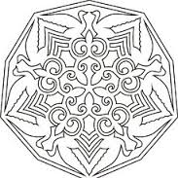

2.
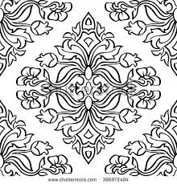

3.
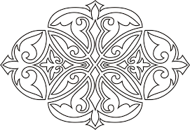

4.
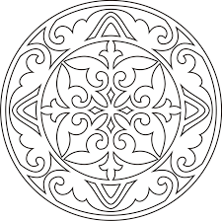

5.
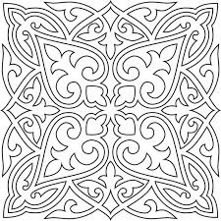

6.
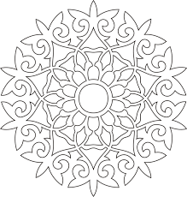

7.
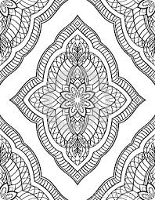

8.


9.
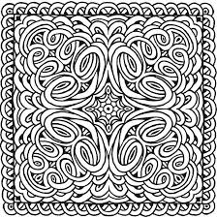

10.
