CLIL ACTIVITY
AUTHOR / SCHOOL | EMMA ABBATE
DATE OF CLIL ACTIVITY | 20/12/2016
CLASS / NUMBER OF STUDENTS | HIGH SCHOOL / 15 LICEO STATALE ALESSANDRO MANZONI
SUBJECT | HISTORY
CLIL Activity Topic | FASCISM AND NAZISM
CLIL Activity Time | 50 min.
Language Objectives | PAST SIMPLE
Language used for communication (BICS) | 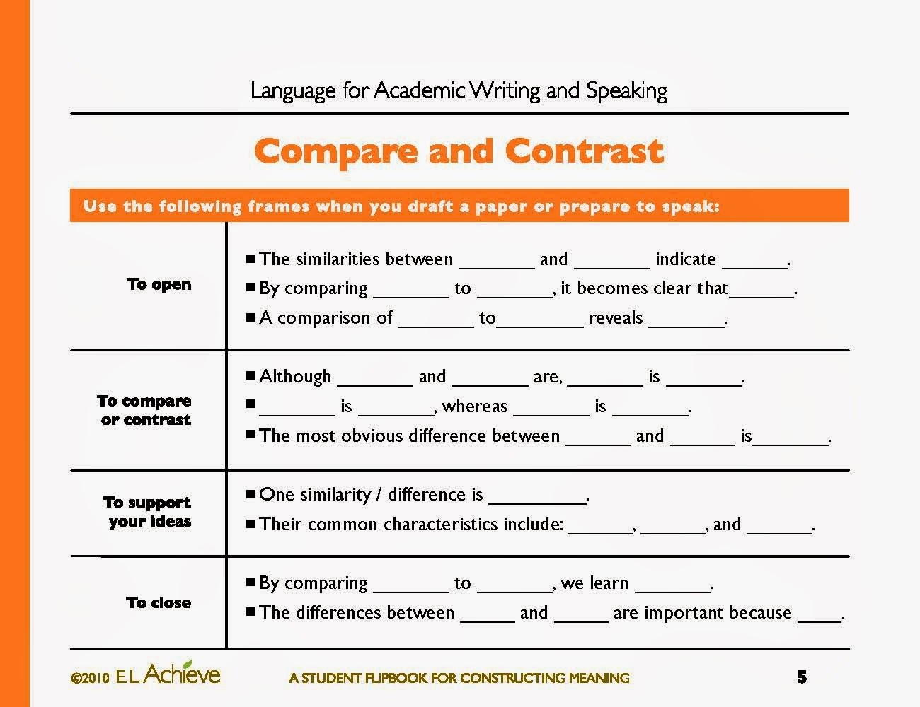
Content Language (CALP) | Police state, Caesarism, Stalinism, absolutism, authoritarianism, despotism, dictatorship, monocracy, one-man rule, shogunate, tyranny….
Content Objectives/Cognition  (What thinking skills are needed of learners?) | Comparing and contrasting Fascism and Nazism
Materials / Resources used | INTERNET  BUBBL.US
CLIL Activity - | Read the article on http://www.heeve.com/modern-history/difference-between-fascism-and-nazism.html to create a mind map using https://bubbl.us/ on differences between Nazism and Fascism
Performance Assessment of students | ASSESSMENT CRITERIA FOR MIND MAP  1stlevel concept links (2 point for each if valid)  2ndlevel concept links (4 point for each if valid  3rdlevel concept links (6 point for each if valid)  4thlevel concept links (8 point for each if valid)  Cross links (10 point for each if valid)  Examples (1point for each if valid)  Relationships (3 point if valid)  Picture, Image and Figure (3 point if valid)  Invalid component (0 point)
Cultural Aspect(s) | if applicable compare the content with English speaking countries context (e.g. decimal point or comma, etc.)

¹ Try to start a lesson by finding what your learners know about the topic. Sometimes it is hard for them to use L2. Make them feel free to use L1 and then translate (use scaffolding -see What is CLIL
² WRITE THE WORDS or PHRASES ON THE BOARD AND CHECK WHETHER THEY ARE PRONOUNCED CORRECTLY BY YOUR LEARNERS (choral and/or individual repetition)
³ Do not forget to state WHILE-ACTIVITY TASKS (e.g. find the answer for the questions.../give me the main idea of the text/video/recording.../how many times is/are .....mentioned in the text/video/recording...)

4 an activity = pre- , while- , post- activity tasks ( an activity = a brick of a lesson = a lesson

http://grupsderecerca.uab.cat/clilsi/content/all-subjects

