CLIL ACTIVITY
AUTHOR / SCHOOL | EMMA ABBATE LICEO STATALE ALESSANDRO MANZONI CASERTA
DATE OF CLIL ACTIVITY | 11/1/2017
CLASS / NUMBER OF STUDENTS | SECONDARY / 15
SUBJECT | ART
CLIL Activity Topic | Greek pottery
CLIL Activity Time | 10 min
Language Objectives | passives - is done, are made...  Expressions to illustrate the myths on vases  Expressions for describing objects.
Language used for communication (BICS) | - passive forms(it was made in the … century…they were used in ceremonies..),  - connectives for reasoning (Decorated art work was used in ceremonies because the Greek rulers wanted to obtain the benefit of Gods…..)
Content Language (CALP) | line, shape, patterns, vases, carvings, pottery , ceramics….
Content Objectives/Cognition  (What thinking skills are needed of learners?) | Identifying the decorations on greek pottery
Materials / Resources used | Computer
CLIL Activity - | 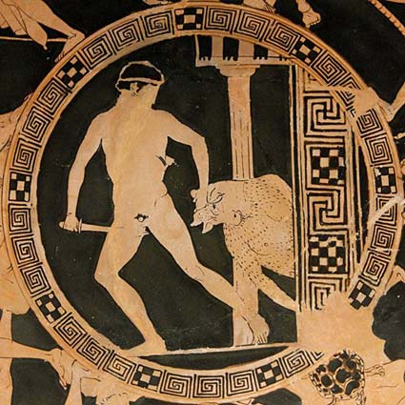  http://www.canino.info/inserti/monografie/etruschi/miti/teseo/  The teacher write on the blackboard the question:  What do you see in the picture?  The students in pair discuss the answers. Teachers control the language.  Scaffolding: The students are given setences frames on a separate sheet.  In the picture I can see ...  There’s / There are ...  There isn’t a ... / There aren’t any ...  Say what is happening with the present continuous  The man is ...ing  Where in the picture?  At the top/bottom of the picture ...  In the middle of the picture ...  On the left/right of the picture ...  next to  in front of  behind  near  on top of  under  If something isn’t clear  It looks like a ...  It might be a ...  He could be ...ing  Maybe it’s a ...
Performance Assessment of students | Individual assessment: Exercises will be assessed according to the correctness of the answers
Cultural Aspect(s) | if applicable compare the content with English speaking countries context (e.g. decimal point or comma, etc.)

¹ Try to start a lesson by finding what your learners know about the topic. Sometimes it is hard for them to use L2. Make them feel free to use L1 and then translate (use scaffolding -see What is CLIL
² WRITE THE WORDS or PHRASES ON THE BOARD AND CHECK WHETHER THEY ARE PRONOUNCED CORRECTLY BY YOUR LEARNERS (choral and/or individual repetition)
³ Do not forget to state WHILE-ACTIVITY TASKS (e.g. find the answer for the questions.../give me the main idea of the text/video/recording.../how many times is/are .....mentioned in the text/video/recording...)

4 an activity = pre- , while- , post- activity tasks ( an activity = a brick of a lesson = a lesson

