AUTHOR / SCHOOL | Silvija Mickeviča  methodologist of bilingual education/Education Department  Ludmila Lastovka (English teacher),  Izuļena Nataļja (Geography teacher)  Daugavpils Russian secondary school-lyceum
DATE OF CLIL ACTIVITY | 28.09.2016.
CLASS / NUMBER OF STUDENTS | 7 th grade (13 years old pupils)  20 pupils
SUBJECT | geography
CLIL LANGUAGE | English
CLIL Activity Topic | Rainforests in Africa. Layers, animals, plants
CLIL Activity Time | 50 min.
Language Objectives | - to ask and answer questions  - to read for specific information  - to summarize ideas in writing
Language used for communication (BICS) | There is / there are  Wh –questions in present simple  Comparative adjectives  types, annual  numbers, square miles/ kilometres
Content Language (CALP) | temperate, tropical zones, rainfall, stability, nutrients, soil, decay  layers: forest floor, understory, canopy, and emergent layer  plants: fungi, epiphytes, saplings, broadleaved, hardwood evergreens, overlapping,vines  names of animals: Jaguars, Leopards, Fruit Bats, Boa Constrictors, Hummingbird, Giant Armadillos, and Giant Anteaters and etc.
Content Objectives | - to find out specific information about rainforests  - to identify the layers of the rainforests  - to classify the information  - to define the rainforests on the map
Materials / Resources used | Sounds of rainforests: https://www.youtube.com/watch?v=-IAfg_Iy7n8  Worksheet  Handout 1,2,3,4, 5  scissors, glue stick  Resources:  http://www.srl.caltech.edu/personnel/krubal/rainforest/Edit560s6/www/whlayers.html  http://www.rainforestanimals.net/rainforest.html  http://www.enchantedlearning.com/subjects/rainforest/Where.shtml
CLIL Activity - procedure | Warming up (5 min.)  Ask pupils to close eyes, switch on the sounds of rainforest, after some minutes ask to open eyes and say what sounds they heard (birds singing, rain, thunderstorm, animals). Ask where they can hear these sounds. (Rainforest)  Activity 1,2, 3, 4 (15 min.)  Ask pupils to colour the rainforests on the map, then ask to write what they know about rainforests in the facts file. (Worksheet). Then ask to write questions about the missed information. (Ex.: What are the types of rainforests? Where are the rainforests located?)  Arrange pupils in groups of three pupils, give cards with texts (A, B, C – Handout 1), give time to read the information and fill in the facts file with the missed facts. Then pupils share the information with each other asking and answering questions. Motivate pupils to speak without showing the paper.  Check with all class –problematic answers must be explained (also the correct answers could be displayed on the screen or written on the board).  Activity 5 (10 min.)  Ask pupils if they know about the layers of rainforest:  How many layers are there in the rainforest?  Can you name these layers?  Give Handouts 2, 3 ask to read information about layers, underline the main features of these layers. On the worksheet pupils label the names of layers, height and their characteristics in brief. Check answers with the whole class.  Activity 6 (10 min.)  Give pupils Handouts 4 and 5, ask to find out what animals and plants can be found in the rainforest of Africa. Then pupils cut out the pictures of animals and stick them in the appropriate box (layer), write the names of plants. Ask pupils to compare the answers with the neighbour. Monitor the class and help with difficult words.  Activity 7 (10 min.)  For this activity draw the layers of the rainforest on the board.  Ask pupils to look at the notes they have done in the layers and write what layer they would prefer to live and give at least three reasons why.  Give pupils a small sheet of paper, ask to write his/ her name and the name of layer. Pupils go to the board, stick the paper next to the appropriate layer and explain why they would like to live there.
Performance Assessment | Activity 4 could be prepared as the evaluation task.
TEACHER´S NOTES | Music of rainforests could be played during the lesson creating relaxing environments in the class.

Worksheet
Name …………………………………………………………………………. date ………....
Rainforests of Africa

1 Colour the tropical rainforests green on the map.

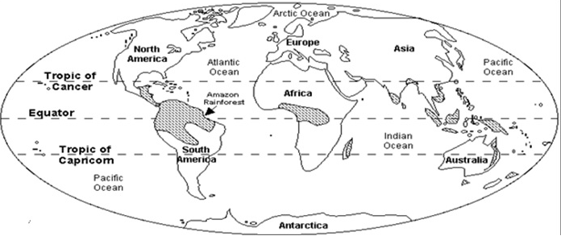
2 Fill in facts file about tropical rainforests in Africa. Write facts that you know.
Facts File:

Types:
Location:
Area:
Climate:
Why important:
Other interesting facts:

3 Write questions for the missed parts.

4 Group work.
Read the paragraph, fill in the missed information in your facts file. Ask questions to your group mates and complete the table.

5 Read the information about layers, underline the main features (Handout 2) label the layers of the rainforest write the most important information in brief.

6 Look at Handout 3, write the names of plants in the appropriate box. Stick the pictures of animals (Handout 5)

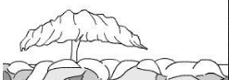

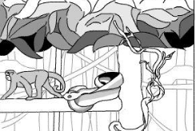
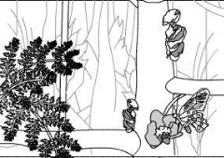

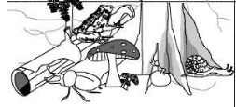

7 Look at your notes, summarize your ideas. Choose one of the layers. Write at least three reasons why you would like to live in one of the layers. Present your ideas to classmates.

Handout 1
A Location of the rainforests
There are two types of rainforests on our planet. They are temperate and tropical. Tropical rainforests are located along the equator and temperate rainforests are found in the temperate zones around the world. Over 50 % of all tropical rainforests are situated in South America and a third of those can be found in Brazil. Other tropical rainforests can be found in South East Asia, some Pacific Islands and in West Africa. The biggest temperate rainforests are situated in North America on the Pacific coast and smaller ones can be found in Chili, Australia, New Zealand, Japan, Norway and the United Kingdom. African rainforest can be found across east, central, and West Africa and cover over 2.2 million square miles (3.6 million square kilometers). Approximately three quarters of Africa's rainforest are located in central Africa. Also there are rainforests in Cameroon, Congo, Democratic Republic of Congo (Zaire), Central African Republic, Madagascar, Gabon, Ghana, Ivory Coast, Liberia, Nigeria.
B Climate in the rainforests
Tropical rainforest are warm and wet. This life zone is characterized by a huge diversity of plants and animals and by high amounts of annual rainfall. These regions typically have annual rainfall of 50-260 inches (125 to 660 cm). Compared to other rainforest throughout the world the rainforests in Africa are dry. They receive between 63 and 78 inches (160 and 200 cm) of rainfall per year compared to the Amazon's average rainfall of eighty inches (2032 mm).
The temperature in a rainforest rarely gets higher than 93 degrees Fahrenheit (34 degrees Celsius) or falls below 68 degrees Fahrenheit (20 degrees Celsius).
C The importance of rainforests
The rainforests are very important for us. We need them! The trees and other plants in the forest help to make the air that we breathe. Rainforests are responsible for twenty eight percent of the world's oxygen production.
They also help to control the weather. Tropical Rainforest are an important source of the world’s fresh water. In fact the Amazon Basin is the source of one fifth of the earth’s fresh water. They give us wood, rubber, fruits and many of our medicines.
About 75% of all the types of animals that we know come from rainforests. Thousands and thousands of animals live in rainforests. There are many very beautiful birds, insects and reptiles. Many of them live in the trees, over 30 metres from the ground. There are also thousands of different plants – and lots tall trees could be found on different layers of the rainforest.

Handout 2

Layers:

Emergent Layer

Canopy Layer

Understory Layer

Forest Floor Layer

The canopy, which may be over 100 feet (30 m) above the ground, is made up of the overlapping branches and leaves of rainforest trees. Their roots don't reach the ground. These are called air plants. The conditions of the canopy are very different from the conditions of the forest floor. During the day, the canopy is drier and hotter than other parts of the forest. | The understory is a ‘halfway house’ between the forest floor and the canopy layer. The plants in this area seldom grow to 12 feet. The understory consists of leafy bushes, small trees, saplings (young trees) and vines. The plants that grow here tend to have large leaves, to capture what little light is available to them; the understory layer only gets 5% of the rainforest’s sunlight.
The very top layer is called the emergent layer. The tallest trees in the rain forest get the most sun and rain. The tops of some of the tallest trees stick up above the main “roof” or canopy layer. These trees can reach heights of 150 to 250 feet (45.7-76.2 meters). Trees in this layer may get the most sunlight, but they also are exposed to more wind and lots of rain. | The forest floor is a dark, damp and hot place full of many dead leaves, twigs and dead plants. Only 2% of the sunlight that falls on a rainforest reaches the forest floor. Surprisingly, rainforest soil isn’t very rich in nutrients. This is why rainforest trees need wide – rather than deep – roots. They provide stability in the thin rainforest soil, and also help the trees to find the nutrients they need.

Handout 3

Forest Floor Layer  Because of the extreme lack of sunlight that is able to reach the Forest Floor Layer, very little is able to grow here. The air is humid and there is no wind or breeze. Leaves and other organic matter decay very quickly in such a dark, damp and still environment. Fungi can feed on the decaying matter as other numerous types of small insects. Scorpions, Green Iguanas, Army Ants, Giant Armadillos, and Giant Anteaters are well adapted to digging their flood out of the ground. |  | The Canopy Layer  Because up to 99% of the sunlight that falls on a rainforest reaches the canopy layer, many plants are found here. Epiphytes (plants that grow on other plants) grow on the branches of trees. Lianas –rainforest vines – also try to reach the valuable sunlight by wrapping themselves around the trunks and branches of trees. Almost 90 percent of the animal species that live in the rain forest live in the canopy, including most bird species. There are also lots of monkeys, sloths, snakes, tree frogs, insects, lizards that live here. Many of these animals never touch the forest floor.
The Emergent Layer  The emergent layer is breezy, wet and lacks shelter. It can also be extremely hot, and is a rather inhospitable place. It doesn’t provide a suitable habitat for many plant or animal species. Most of these trees are broad-leaved, hardwood evergreens. Animals that live in the Emergent Layer do not typically weigh much. The trees have to be able to support the animals as they move around from tree to tree. Animals found are eagles, monkeys, bats and butterflies, sloths and spider monkeys, Hummingbird, the smallest bird on earth ( They are known for beating their wings so quickly that it makes a humming sound. They also have an extremely fast heart rate that beats between 50 and 75 times per second.); the brightly colored Macaw (They eat a variety of nuts, seeds, fruits, and insects); the bird-eating tarantula, Harpy Eagle, bats, snakes, butterflies, and various insects. |  | The Understory Layer  The understory consists of leafy bushes, small trees, saplings (young trees) and vines. The plants that grow here tend to have large leaves, to capture the little light that is available to them. The Understory Layer has a heavy concentration of insects. The hot, damp and humid conditions in this layer are perfect for mosquitoes and other insects to breed and thrive. Red-eyed tree frogs, Jaguars, Leopards, Fruit Bats, Boa Constrictors (among others) all live in the Understory Layer and all use camouflage to disguise themselves. Common house plants that don't require much light such as zebra plants, peace lilies, and philodendrons come from the Understory Layer.

Handout 4
Animals of the African Rainforests



